Guidance notes for hirers when completing a hire application
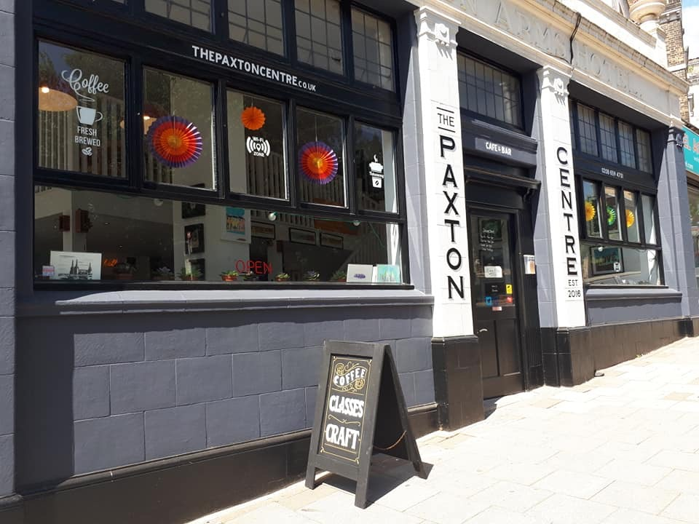
These notes provide you with further information to help you complete you’re booking application. The information you submit will be used to prepare your invoice. If you require any further information, please do not hesitate to contact us on 0208 659 4701.
Further contact details can be found at the end of this info pack.

Contents
- About us
- Hire periods and costs
- Method of booking and payment
- Capacities
- Refundable Damage Deposit
- Catering/Use of Kitchen
- PRS and PPL
- Child Protection Policy
- Your Responsibility’s A & B
- Loss or Damage
- Cancellation or Termination of hire by the hirer
- Cancellation or termination of hire by The Paxton Centre
- Supplementary Conditions of Hire for Regular Users
- Regular Hirers Cancellation

- About us
The Paxton Centre was established in Aug 2016 by Beth as a collective creative community meeting space in Crystal Palace. Our ethos is to support the local economy, skill share and promote collaborations and friendships. We are housed in a beautiful Victorian ex Public House ‘The Paxton Arms Hotel’ built in 1857 which is the only original building on Palace Road corner of Anerley Hill. It closed as a pub in 2013 and was refurbished into the space we occupy today, keeping the original featured high ceilings and windows giving its lovely spacious and light interior.
We offer a space for artists and designers to exhibit and sell their work on a monthly basis in our vibrant gallery space. The timetable of artist led craft workshops provides a range of interest for adults, children and groups. Our vibrant licenced café serves locally sourced excellent food and of course coffee!
Various spaces are available to hire for your meeting, workshop, event or celebration.
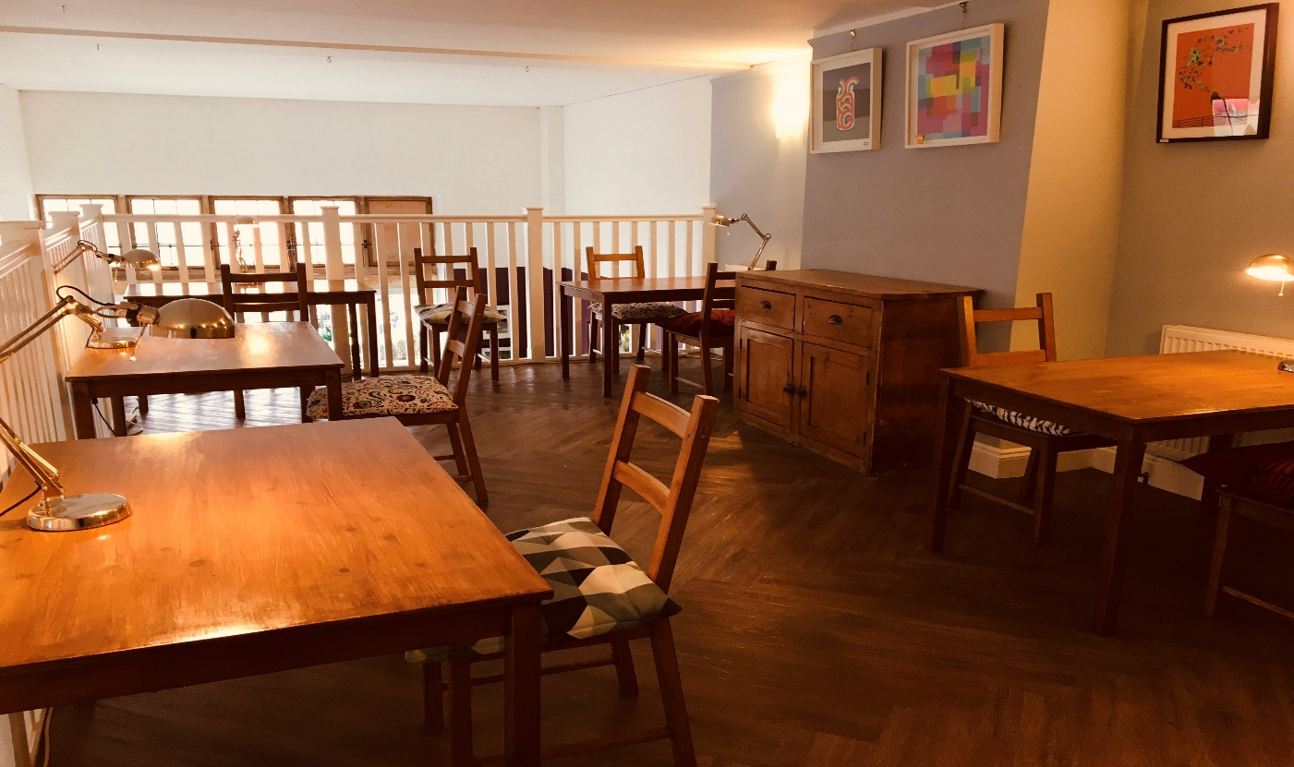
The Mezzanine is a bright and a lovely little space suitable for workshops, courses small meetings and events.
£25 per hour - min 3 hours hire.
Private Hire Available: Wed & Thu 6pm to 9pm - Sat 1pm to 5pm - Sun 10am to 5pm

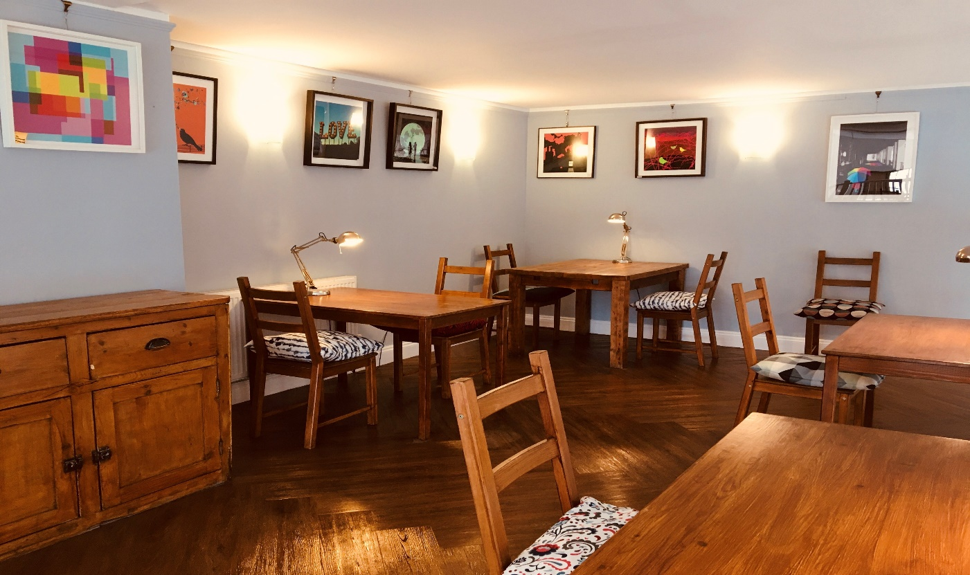
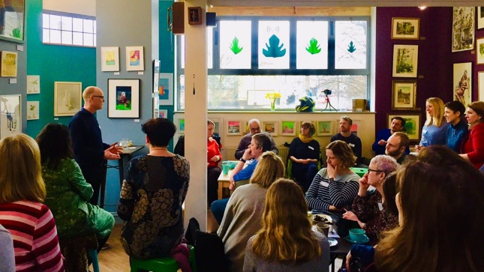
Main Area is suitable for parties, live music, meetings, social events and celebrations.
£50 per hour - min 5 hours hire.
Hire Available: Wed, Thu, Fri 6pm-12pm - Sat & Sun 12pm-12am (event depending)
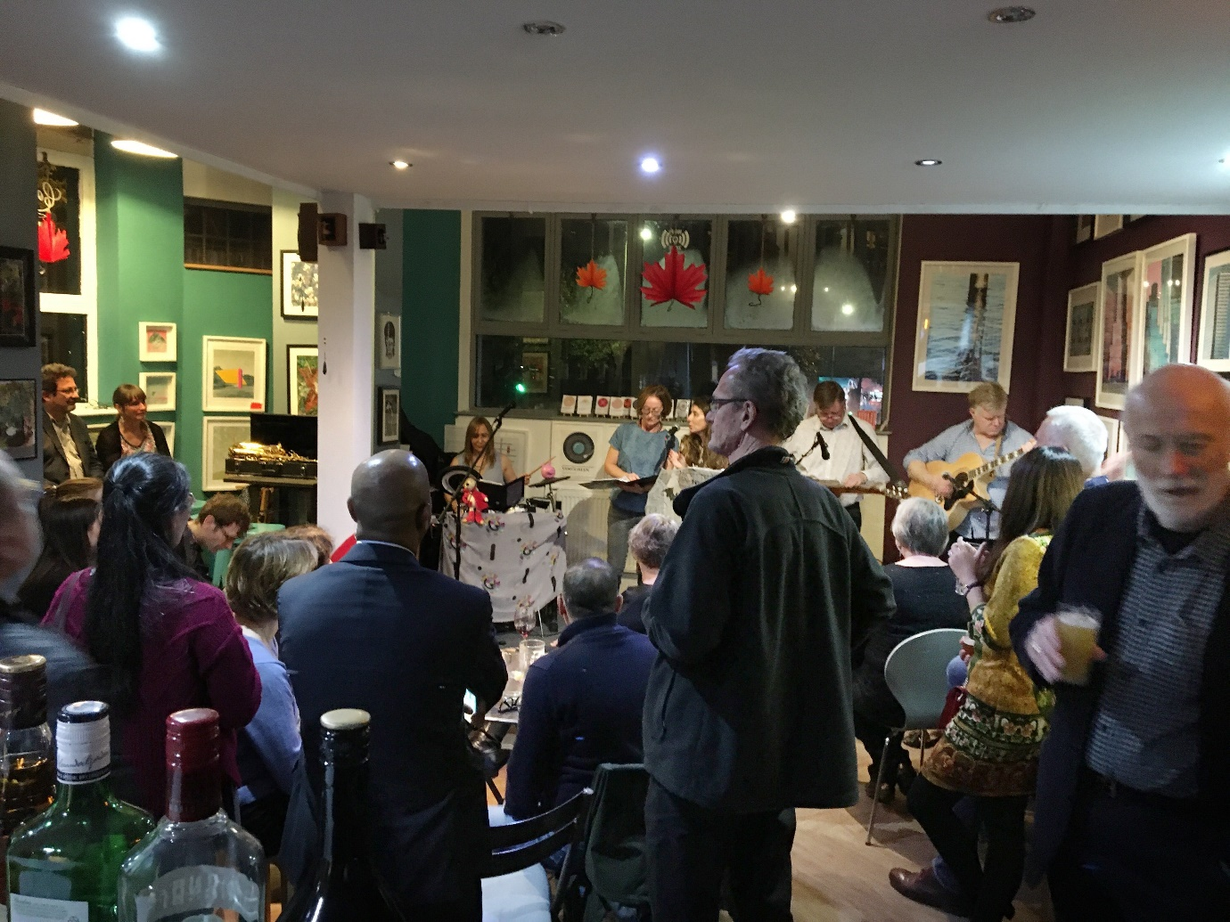
*Please note hire times must include any set up and pack down time to allow you to set out and vacate the premises at the end of your hire time. We hire to the half hour.
PLEASE NOTE WE OPERATE A PAID BAR FOR ALL EVENTS TO PURCHASE ALCOHOL, SOFT AND HOT DRINKS. WE ARE LICENCED TO 11PM. YOU CAN BRING YOUR OWN FOOD HOWEVER THIS MUST INCLUDE YOUR OWN PLATES, SERVIETTES AND CUTLERY ETC AND ALL WASTE TO BE TAKEN AWAY BY THE HIRER.
*The kitchen area or equipment is not for use by hirers
MINIMUM BAR SPEND
In addition to the hourly hire rate, we charge a minimum spend on refreshments. This is calculated at £10 per person guided by your attendee numbers on the booking form. In the event the café & bar does not meet this amount the shortfall will be paid by the hirer at the end of the event.

• Capacity
The Paxton Centre cannot accept responsibility for numbers being over the stated capacity. Failure to comply will potentially result in the function being cancelled immediately.
(The numbers given are the maximum permitted according to fire safety regulations).
MEZZANINE – 20 people seated or standing
MAIN SPACE – 40 to 50 people standing with limited seating
60 people in total – if booking both
The main area and mezzanine can be hired together for larger events.

- Method of Booking and Payment
- You have indicated that you wish to book space at the Paxton Centre. All necessary paperwork has been enclosed.
- Please complete all sections of the bookings form.
- On receipt of the completed bookings form, an invoice will be raised requesting a Non-Refundable Payment for 25% of the total amount (or full payment if your booking is within 2 Months.

Please note: - The 25% deposit will need to be paid immediately as your booking cannot be guaranteed until your deposit has been received. The remaining 75% together with your Damage Deposit are due 2 months before your event.

Deposits are not transferable or refundable.
You can pay your deposit or balance at the Centre by credit or debit card or cash or alternatively this can be done by bank transfer.
Credit or Debit card: - Payment can take place at the Centre or over the telephone between 10am – 5pm. All data is kept secured and is not given to third parties. There is no charge for using a debit card or credit card however we do not accept Cheques or American Express
Cash: - Monday– Sunday 10am – 5pm
Bacs: - Acc: 58368568 Sort: 30-91-92 please use date of hirer as reference number.

Refundable Damage Deposit
A Refundable deposit of £50.00 is required on all bookings as a guarantee against
- Damage
- If the hirer does not vacate by the agreed time on booking
- Failure to comply with the conditions of hire including entry & exit times

Payments made by cash or credit/debit card can be refunded on the Monday after your booking subject to these conditions being met. Please note all card refunds are made to the card they were paid with.
We will take every precaution to notify you of any damage on the evening. In some cases, particularly where the evening is busy, staff may fail to notice damage and this may only be noticed during the following day. In these circumstances, a member of staff will contact you providing further details.
- PRS and PPL
The Performing Rights Society (PRS) works on behalf of music composers and publishers to ensure that all royalties due on copyright are paid. A fee is payable for any booking where music (live or recorded) is played within the exception of family or domestic gatherings. Fees vary depending on the nature of the event and are incorporated in the charges.
- Child Protection Policy
For hirers who wish to organize activities for young persons under the age of 11 years, you will need to be fully aware of your responsibilities for protecting children under your control. To continue with any hire agreements and/or to renew existing agreements, you will be requested to provide an update of your policy and/or confirmation that you will adhere to the Paxton Centre Policy.

- Your Responsibility’s
During the period of hire specified: YOU SHALL NOT
- Bring NO drinks onto the premises unless prior agreement has been made
- NO smoking anywhere inside
- The Paxton Centre operates a zero tolerance drugs policy.
- Make any alteration or addition to the lighting and power at the premises.
- Allow any fires or appliances with naked flames including candles without prior permission.
- Insert or apply any nails, tacks, glue or other substance to any part of the premises.

YOU SHALL
- Leave the premises on time.
- Remove all your belongings.
- Indemnify The Paxton Centre against any loss or damage to the premises, equipment or other property.

- Loss or Damage
Where you or any guests cause damage to the premises or equipment or other property belonging to The Paxton Centre, you will be required to meet the ENTIRE costs of such loss or damage and for these purposes The Paxton Centre may retain all or part of the damage deposit.
- Cancellation or Termination of hire by the hirer
If you wish to cancel your booking you may do so by writing to The Paxton Centre 52, Anerley Hill, London, SE19 2AE or by email thepaxtoncentre@gmail.com and upon receipt of such notice The Paxton Centre will give a refund of
75% Up to 2 months
50% Up to 1 months
25% Up to 2 weeks
The Paxton Centre will retain the initial 25% non-refundable deposit paid.
Please be aware that deposits are non-refundable and non-transferable.

- Cancellation or termination of hire by The Paxton Centre
- The Paxton Centre may refuse any application for hire without giving a reason
- The Paxton Centre may terminate any agreement of hire at any time up to and including the date of hire if:
- The premises are required for the purpose of any Parliamentary, local or European election.
- In the event of such cancellation or termination of hire, The Paxton Centre’s liability will be limited to a full refund of deposit monies and any other payments made by you. It will not be liable to compensate you for any consequential financial or other loss whatsoever arising directly or indirectly as a consequence of such cancellation.

- Supplementary Conditions of Hire for Regular Users
- For hirers who have requested a number of dates throughout the year, an application form together with a calendar will be sent to you requesting that you submit the dates that you require. We will confirm the dates that you have requested by sending you a confirmation email summarizing the bookings details. Once your bookings form has been returned, we will fix your dates and prepare invoices based on the dates and times required. Any subsequent changes to your booking must be made in writing or email.

- Notification of cancellations less than two weeks in advance will require the full hire fee to be paid.
- Invoices will be done one month ahead
All late payments will be subject to an administration fee of £5.
- Invoices will be payable one Month in advance.
- Regular Hirers Cancellation
If you wish to cancel the hiring you may do so by writing to The Paxton Centre and upon receipt of such notice, we will give a full refund provide at least one months prior to the date of the booking is given. Failure to comply will result in the full amount being retained by The Paxton Centre.

Nearest BR stations: Crystal Palace Train Station 100 yards opposite.
Anerley Station (10 min walk)
Buses: 432,249,157 stop outside

enquires and bookings contact:
The Paxton Centre
52 Anerley Hill
Crystal Palace
London, SE19 2AE
Tel: 020 8659 4701
Email: thepaxtoncentre@gmail.com

